Practical No: 07

**Aim:** Raspberry Pi Module GPS Interfacing.

**Hardware Required:**

1. Raspberry Pi 3B+
2. Ethernet Cable
3. Monitor
4. HDMI to VGI convertor
5. Micro SD card (any class best is class 10)
6. Adaptor with 5v 2A
7. USB mouse
8. USB keyboard
9. Relay board
10. Female – Female jumper wires. (4 numbers)
11. GY-GPS6MV2

**Software Required:**

1. Rapbeian OS
2. Thonny Python IDE

**Procedure:**

1. **Hardware Setup:**

* Connect the pins as given bellow….
* **GPIO15** connects to Pin **Rx**.
* **GPIO16** connects to Pin **Tx**.
* **Pin6** connects to Pin **GND.**
* **Pin2** connects to Pin **VCC**.

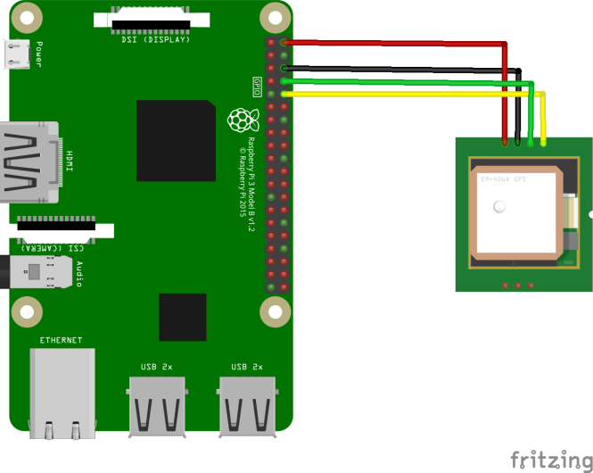

1. **Software Setup:**

* Navigate to Start 🡺 Preferences 🡺 Raspberry Pi Configuration 🡺 Interfaces

Enable Serial and click on OK .

* Type the following code in the terminal…
* sudo pip install pynmea2
* Before typing the code we must ensure GPS is communicating with raspberry pi or not. Type the following code to check it works or not.
* sudo cat /dev/ttyS0

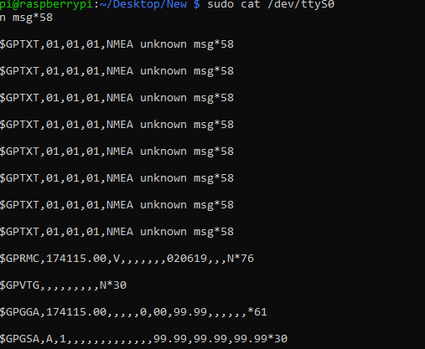

* Open any editor you like and type the following python code

*from time import sleep*

*from serial import Serial*

*import string*

*import pynmea2*

*import webbrowser*

*port = "/dev/ttyS0"*

*ser = Serial(port, baudrate = 9600)*

*longitude_list=[]*

*latitude_list=[]*

*run=True*

*def longitude_average(longitudes):*

*return sum(longitudes)/len(longitudes)*

*def latitude_average(latitudes):*

*return sum(latitudes)/len(latitudes)*

*while run:*

*try:*

*data=ser.readline()*

*if(data[0:6]=='$GPGGA'):*

*msg=pynmea2.parse(data)*

*lon=float(msg.lon)/100*

*longitude_list.append(lon)*

*lat=float(msg.lat)/100*

*latitude_list.append(lat)*

*strings="Lat: "+str(lat)+" Lon: "+str(lon)*

*print(strings)*

*except:*

*averagedLog=longitude_average(longitude_list)*

*averagedLat=latitude_average(latitude_list)*

*print("Averaged Logitude: "+str(averagedLog)+" ""Averaged Latitude: "+str(averagedLat))*

*webbrowser.open("https://www.latlong.net/c/?lat="+str(averagedLat)+"&long="+str(averagedLog))*

*run=False*

* Open a terminal and navigate to the folder where you have save the python file

and run the following command

* sudo python **<filename>.**py

**Precautions:**

* If it is a fresh flash of Raspbian OS “*sudo apt update”* and “*sudo apt upgrade”* is a must thing.
* Connect the components before powering on the device and double check your connections.
* When you are reading and writing to tag make sure you are in close proximity with the RFID.

